***BugNum1:***

**Title**: the (set alert for similar jobs) toggle switch is turned off when the user scroll up

**Severity**: 2-High

**Priority**: 2.

**Bug type**: functional

**Description**: When the user turn the (set alert for similar jobs) toggle switch in a posted job

And scroll the screen up again, Then the toggle is turned off automatically

**Steps**:

1. Open any job post to apply to
2. Scroll down to the (set alert for similar jobs) toggle switch
3. Turn the toggle ON
4. Scroll the screen up to the description
5. Check the toggle switch again

**Expected Behavior**: the toggle switch should be still **ON** and the alert to similar jobs should work properly to this user for the specific job , and when the user click manage alerts button from the popup message , the job should be displayed in the list of job alerts.

**Actual Behavior:** the toggle switch is **OFF** for job(X) but the alert to similar jobs works properly for the job, and when the user click manage alerts button from the popup message of any other job (Y), he will find job (X) displayed in the list of job alerts.

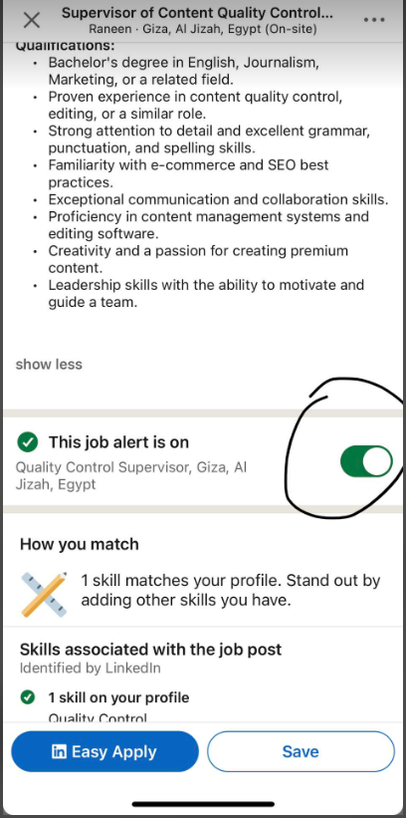**Screenshots:**

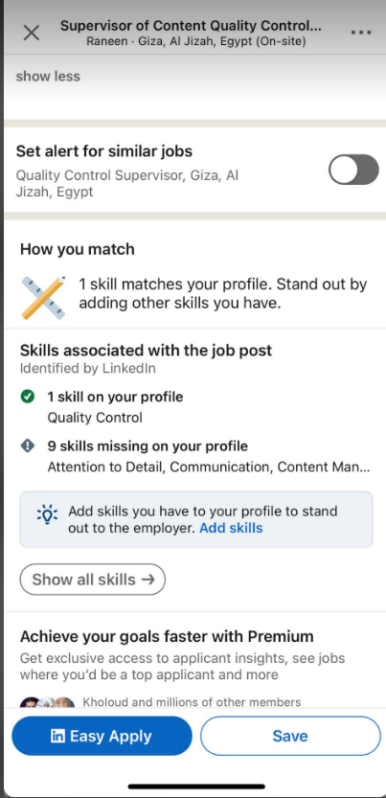

**Network**: Wi-Fi with 5GHz band, **speed** 866/866 (Mbps)

**Device**: IPhone 13, **IOS** 16.6.1

***BugNum2:***

**Title**: the linked in page in the frequently asked Questions of the Premium upgrade redirects to Crashed page

**Severity**: 3-medium

**Priority**: 4

**Bug type**: functional

**Description**: When click on the (LinkedIn setting page link) from FAQ in the details of the upgrade to premium, he is redirected to a crashed page then to another screen is displaying the account preferences

**Steps**:

1. Open the job tab
2. Click on ( Try Premium for free) button
3. Skip, the interested in premium page
4. Click more of the Business Card
5. Click on the first Question From the FAQ
6. Click on the setting link
7. Check the redirection of the link

**Expected Behavior** the User should be redirected to the setting page of linked in website to display the answer of the Question

**Actual Behavior:** the user is redirected to crashed page thenthe account preferences page is displayed

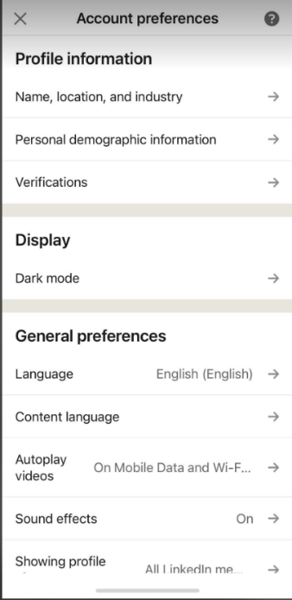**Screenshots:**

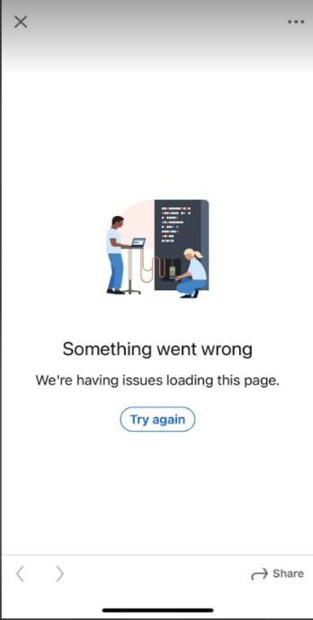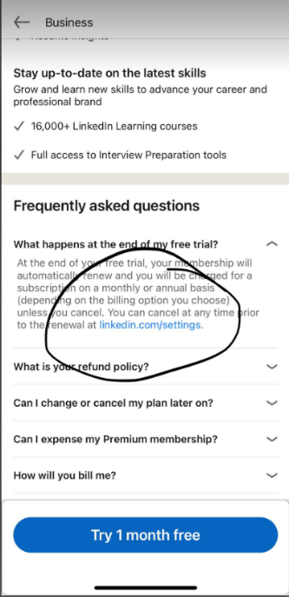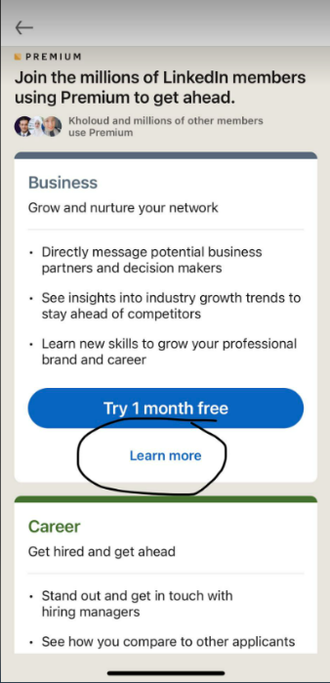

**Network**: Wi-Fi with 5GHz band, **speed** 866/866 (Mbps)

**Device**: IPhone 13, **IOS** 16.6.1

***BugNum3:***

**Title**: incorrect validation message is displayed on the” Additional name” field, when the name exceeds the max length

**Severity**: 3-medium

**Priority**: 3

**Bug type:** Validation

**Description**: When click on the (LinkedIn setting page link) from FAQ in the details of the upgrade to premium, he is redirected to a crashed page then to another screen is displaying the account preferences

**Steps**:

1. Open User Profile
2. Edit User Information data
3. Enter long Name in the Additional Name Exceeds the max num. of characters (50 chars)
4. Check the displayed validation message

**Expected Behavior** the message should be descriptive and mention the correct issue, which is the Name, exceeds the max length

**Actual Behavior:** the message is misleading as attached “invalid content message “

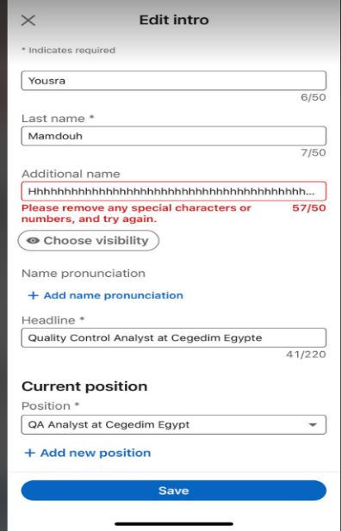**Screenshots:**

**Network**: Wi-Fi with 5GHz band, **speed** 866/866 (Mbps)

**Device**: IPhone 13, **IOS** 16.6.1

***BugNum4:***

**Title**: the Preference is underlined after visit

**Severity**: 4-minor

**Priority**: 4

**Bug type:** UI / Usability

**Description**: When the user click on any preference then returns to the General Preferences list

The selected option is underlined to indicate the visited option

**Steps**:

1. Open Account Preferences list
2. Click on any item from the General Presences list
3. Close the Item screen
4. Check the item

**Expected Behavior** all lists in the app does not underline the visited item of the list

When the user returns back to the list, this should be maintained in all app lists

**Actual Behavior:** the item is underlined when the user return to the list as attached

**Screenshots:**

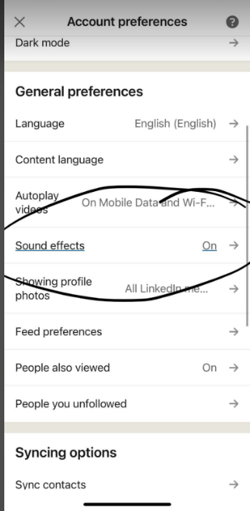

**Network**: Wi-Fi with 5GHz band, **speed** 866/866 (Mbps)

**Device**: IPhone 13, **IOS** 16.6.1